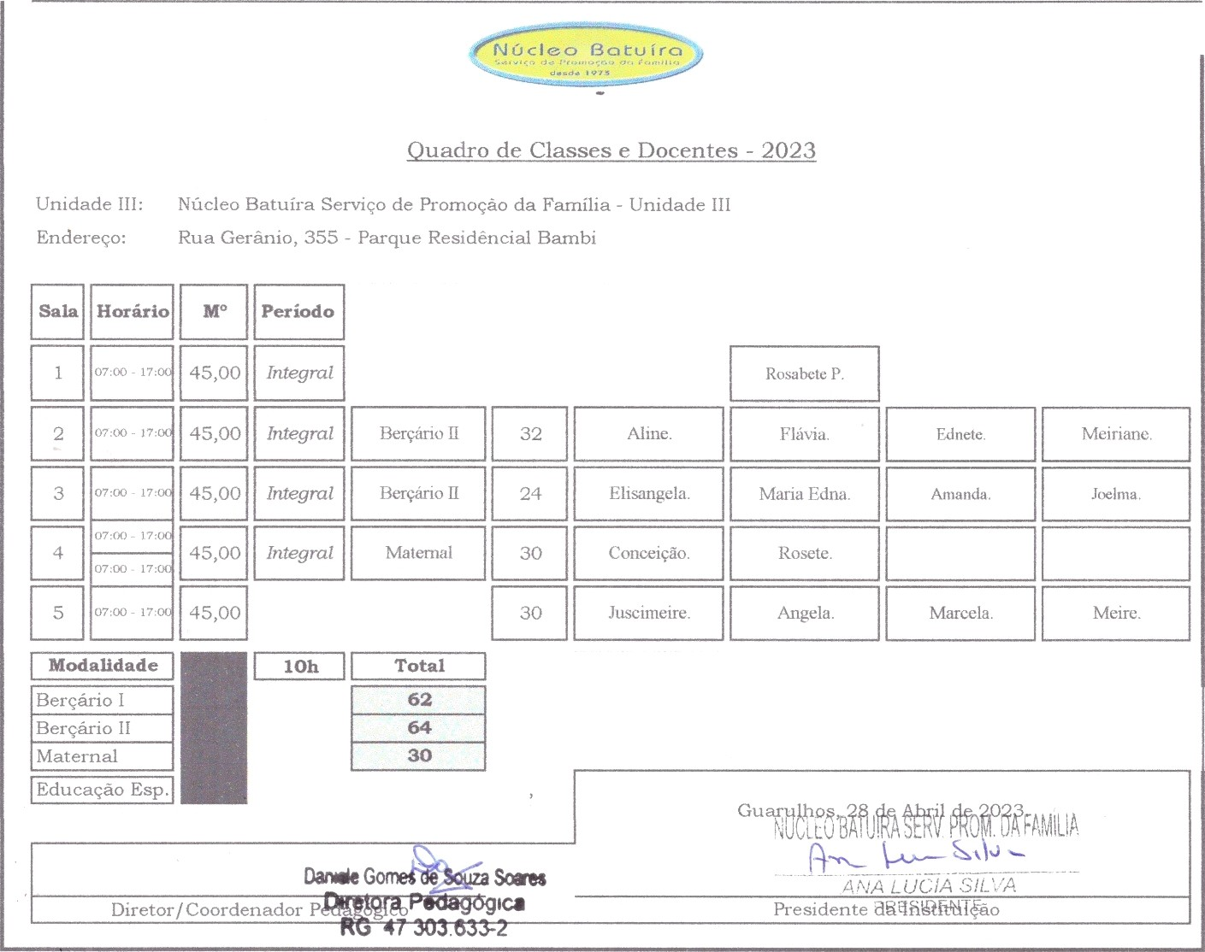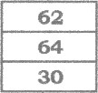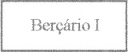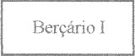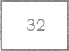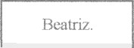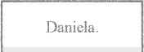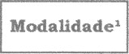
Mod°ttded°'
Rope cfiml Respon•ăvøl Reed cfimJ Rcsponnănl
32
ss

A contratar.
A contratar.

