Exo-EDUc*ç*orTłL-CRECHE

R ê Ri2o ae

eelGeiic daa iBae

dna Nbe
roeRoe
Bata
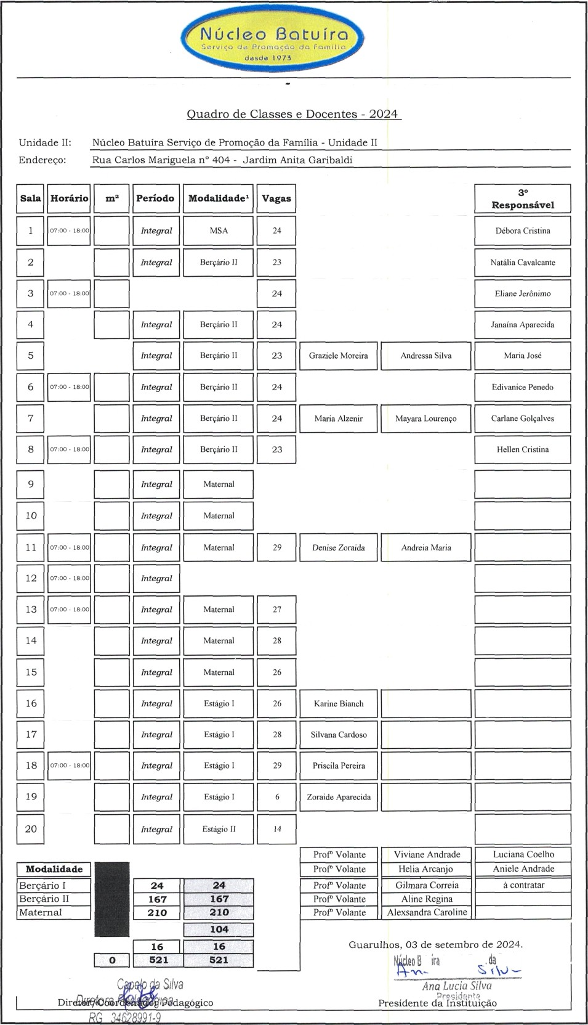
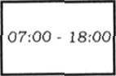
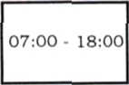
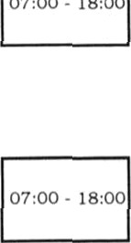
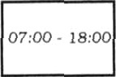
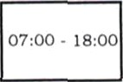
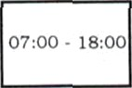
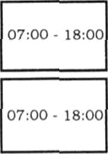
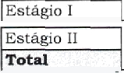
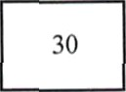
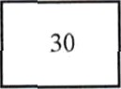
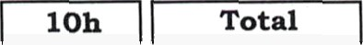
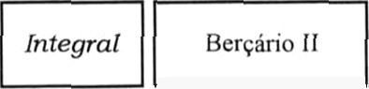
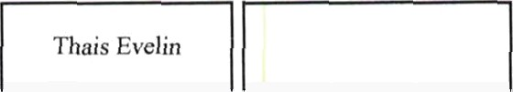

iaRe eeP

C ieRbeo PtcC a

MariadePinho oiaLba

òia Bba

ngrideedo aaizaS

Roaigue PaiiaSa

Mae a eMa | Thai | e
Aa S | Dhce | lea
enierStepae | liabeS | s
iadci led | aBea

